|  |
| --- |
| Experiment No. 13 |
| Program to demonstrate CRUD (create, read, update and delete) operations on database (SQLite/ MySQL) using python |
| Date of Performance: |
| Date of Submission: |

**Experiment No. 13**

**Title:** Program to demonstrate CRUD (create, read, update and delete) operations on database (SQLite/ MySQL) using python

**Aim:** To study and implement CRUD (create, read, update and delete) operations on database (SQLite/ MySQL) using python

**Objective:** To introduce database connectivity with python

**Theory:**

In general CRUD means performing Create, Retrieve, Update and Delete operations on a table in a database. Let’s discuss what actually CRUD means,

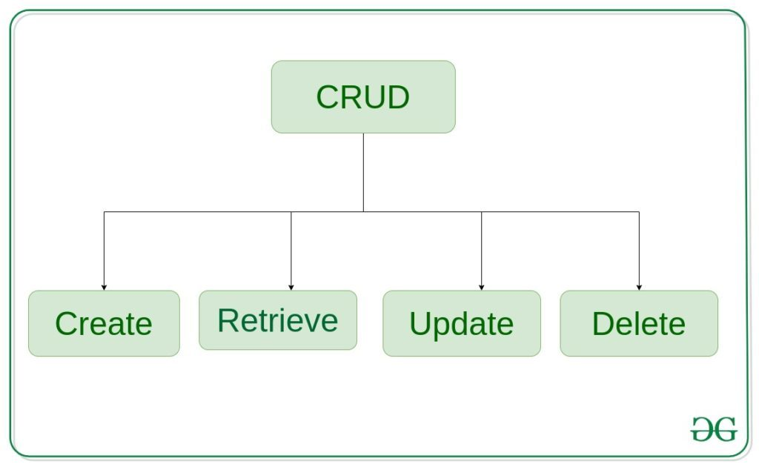

**Create** – create or add new entries in a table in the database.   
**Retrieve** – read, retrieve, search, or view existing entries as a list(List View) or retrieve a particular entry in detail (Detail View)   
**Update** – update or edit existing entries in a table in the database   
**Delete** – delete, deactivate, or remove existing entries in a table in the database

**Code:**

import sqlite3

# Connect to SQLite database

conn = sqlite3.connect('example.db')

c = conn.cursor()

# Create table

c.execute('''CREATE TABLE IF NOT EXISTS users

(id INTEGER PRIMARY KEY, name TEXT, age INTEGER)''')

# Create (Insert) operation

def create_user(name, age):

c.execute("INSERT INTO users (name, age) VALUES (?, ?)", (name, age))

conn.commit()

print("User created successfully")

# Read operation

def read_users():

c.execute("SELECT * FROM users")

rows = c.fetchall()

for row in rows:

print("ID:", row[0])

print("Name:", row[1])

print("Age:", row[2])

print()

# Update operation

def update_user(id, new_name, new_age):

c.execute("UPDATE users SET name = ?, age = ? WHERE id = ?", (new_name, new_age, id))

conn.commit()

print("User updated successfully")

# Delete operation

def delete_user(id):

c.execute("DELETE FROM users WHERE id = ?", (id,))

conn.commit()

print("User deleted successfully")

# Create some users

create_user("John", 30)

create_user("Alice", 25)

# Read all users

print("All users:")

read_users()

# Update user

update_user(1, "Johnny", 35)

# Delete user

delete_user(2)

# Read all users after operations

print("All users after operations:")

read_users()

# Close the connection

conn.close()

**Output:**

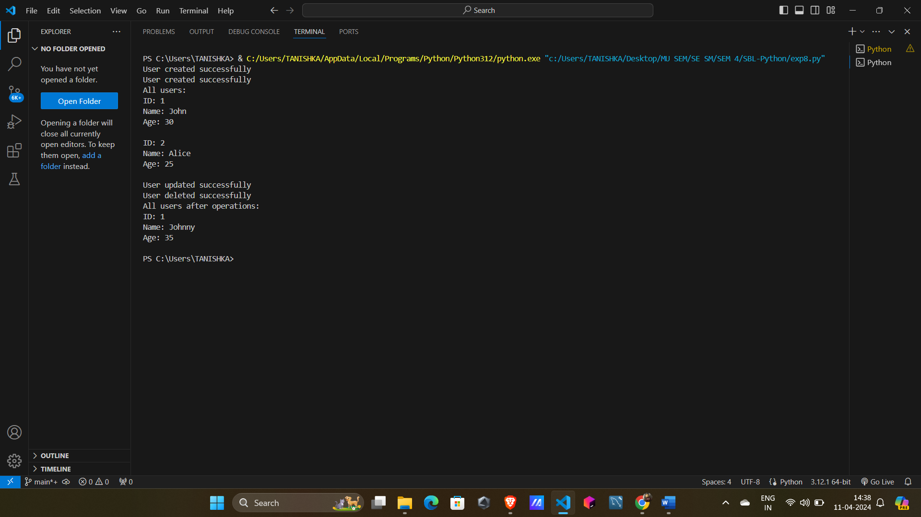

**Conclusion:** CRUD operations has been studied and implemented.